Solid Waste Program Data Migration to LEMIR

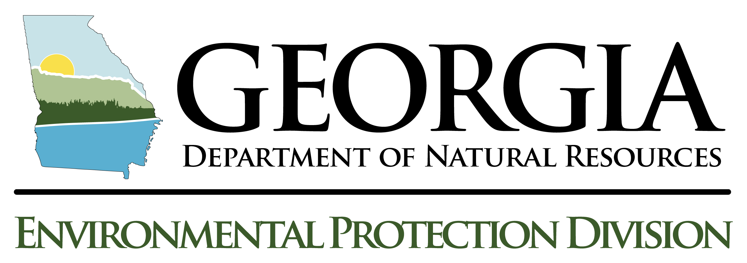

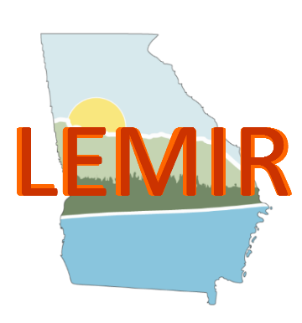

By Michael Heaphy, Project Manager, EPD IT

Tom Karasch, Systems Analyst, EPD IT

# Project Overview

The goal of this project is to move the Solid Waste Program’s data from two separate MS Access databases to the LEMIR Online database system. To achieve this, EPD IT must move the two existing MS Access Databases to SQL Server. Then, Data must be migrated from the two existing databases into a primary staging database that allows EPD IT to merge all data from the two separate databases to a single database, with extra record properties and tables. These additional columns and tables allow EPD IT to determine uniqueness, as well as allow for added Key field identification and other reference information.

# Migration Process Summary

1. Work with the program to determine not only what data to migrate, but also, what data is most important.

# Detailed Scope

# Database Details

# Data Selection Details

# Validation

# Summary

# Avoidable Problems

# Future Process Improvements